OFFICE OF THE PROSECUTOR

SATELLITE IMAGES OF THE AREA NEAR PSSR BLOCK C
OTP DOC/REEF/SAT/001
Compiled by the Office of the Prosecutor in its investigation from publicly available imagery from Earth-observation satellites, covering Day 4 to Day 42. Days are counted from the passage of Hurricane Yolanda (Day 0).

1. ABOUT THESE IMAGES
1.1 The Office searched the publicly available imagery from Earth-observation satellites for the area around PSSR Block C between the resumption of production on Day 4 and the end of the discharge on Day 42.
1.2 Two kinds of image were used: a wide view, taken every day, which shows the whole region at coarse detail; and a sharper image, taken every few days, which shows a smaller area in fine detail.
1.3 Passes on which the sea around the position of the Green Dawn was hidden by cloud are not listed. No pass between Day 26 and Day 32 gave a usable view, because of cloud during and after the storm of Day 28.

2. LOG OF USABLE PASSES

Table 1 — What each usable pass shows
Day | Kind of image | Sky over the area | Near the position of the Green Dawn | Coastal waters
6 | Wide view | Mostly clear | Uncertain: a slightly lighter patch next to the position, at the limit of what the wide view can show | Widespread brown water along the coasts after Hurricane Yolanda; no distinct streak
9 | Sharper image | Clear | Faint grey-brown streak, about 8 nm long, beginning near the position (Image 1) | Not in this image
10 | Wide view | Clear | Faint streak, about 10 nm long | Brown water along the coasts, less than on Day 6; no distinct streak
13 | Wide view | Clear; sun glint over the area | Not seen (sun glint) | Brown water in places along the coasts; no distinct streak
14 | Sharper image | A few clouds | Faint streak, about 6 nm long | Not in this image
17 | Wide view | Partly cloudy | Uncertain: gaps between clouds (Image 2) | Coasts partly under cloud; brown water in places; no distinct streak
19 | Sharper image | Clear; strong wind and whitecaps | Not seen | Not in this image
22 | Wide view | Clear | Faint streak, about 12 nm long | Brown water in places along the coasts; no distinct streak
24 | Sharper image | Haze | Uncertain | Not in this image
33 | Sharper image | Haze after the storm of Day 28 | Not seen (Image 3) | Not in this image
36 | Wide view | Clear | Faint streak, about 15 nm long | Widespread brown water along the coasts after the storm of Day 28; no distinct streak
39 | Sharper image | Cloud over the position | Not seen | Not in this image
2.1 Of the 12 usable passes, a faint streak is seen on 5, the view is uncertain on 3, and nothing is seen on 4. The direction of the streak differs from pass to pass.

3. IMAGES
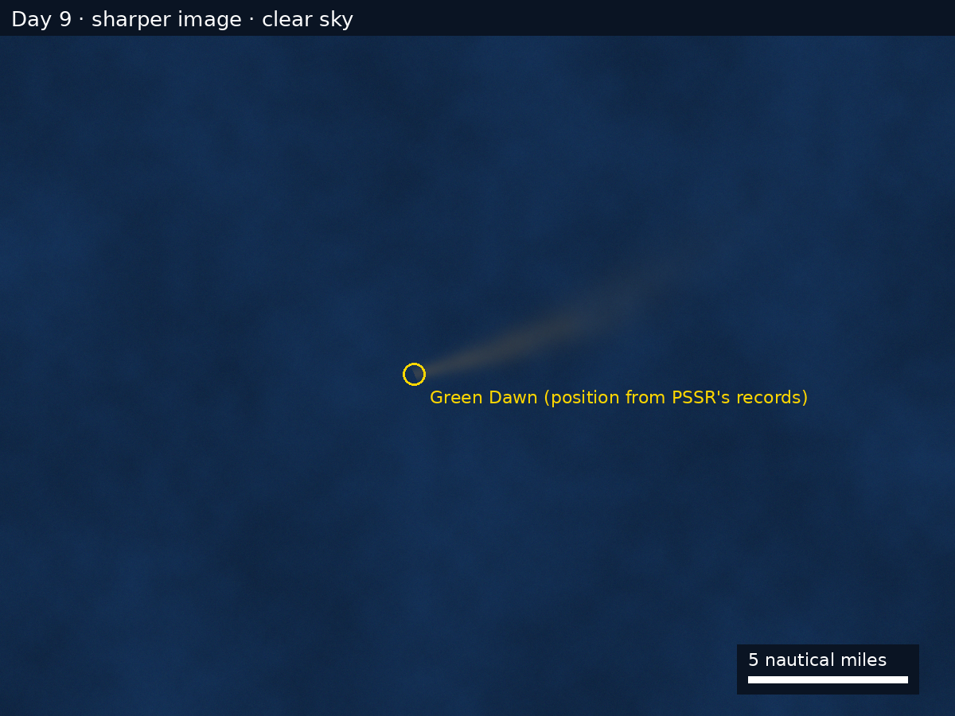
Image 1 — Day 9, sharper image, clear sky. The area shown is about 30 nm across.
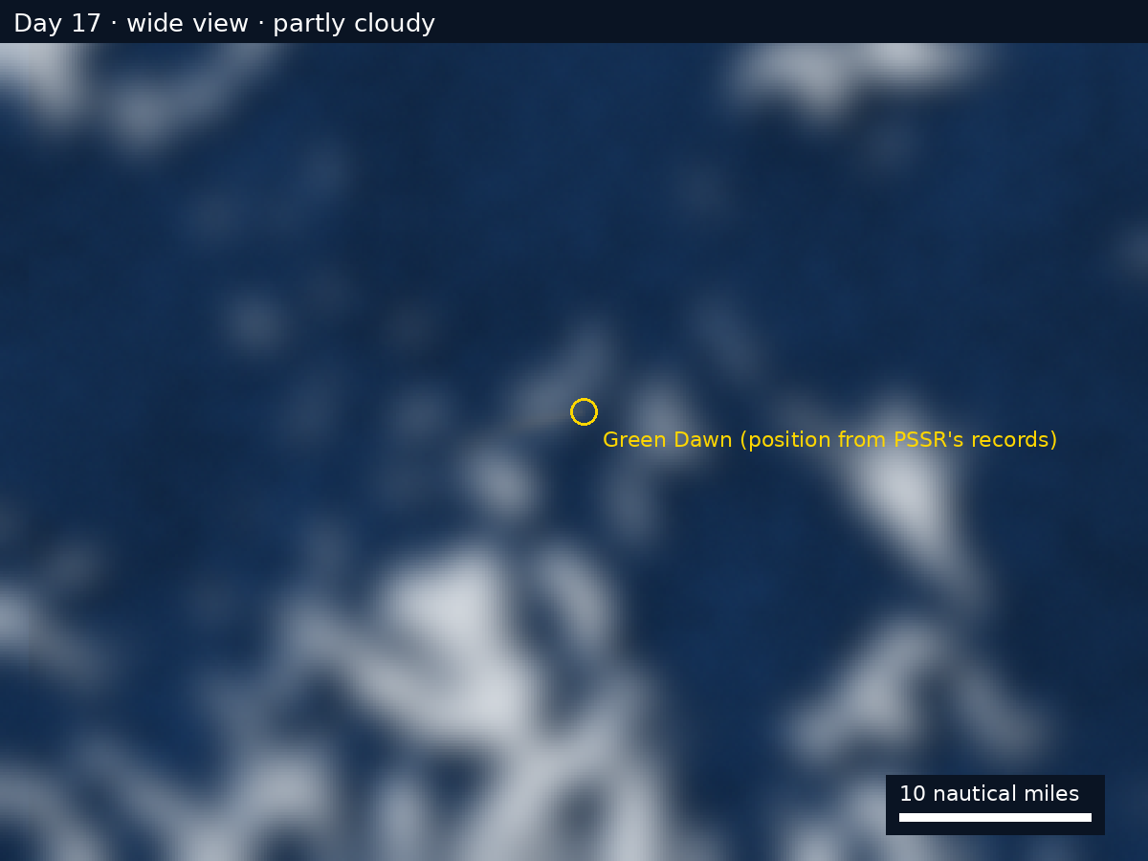
Image 2 — Day 17, wide view, partly cloudy. The area shown is about 60 nm across.
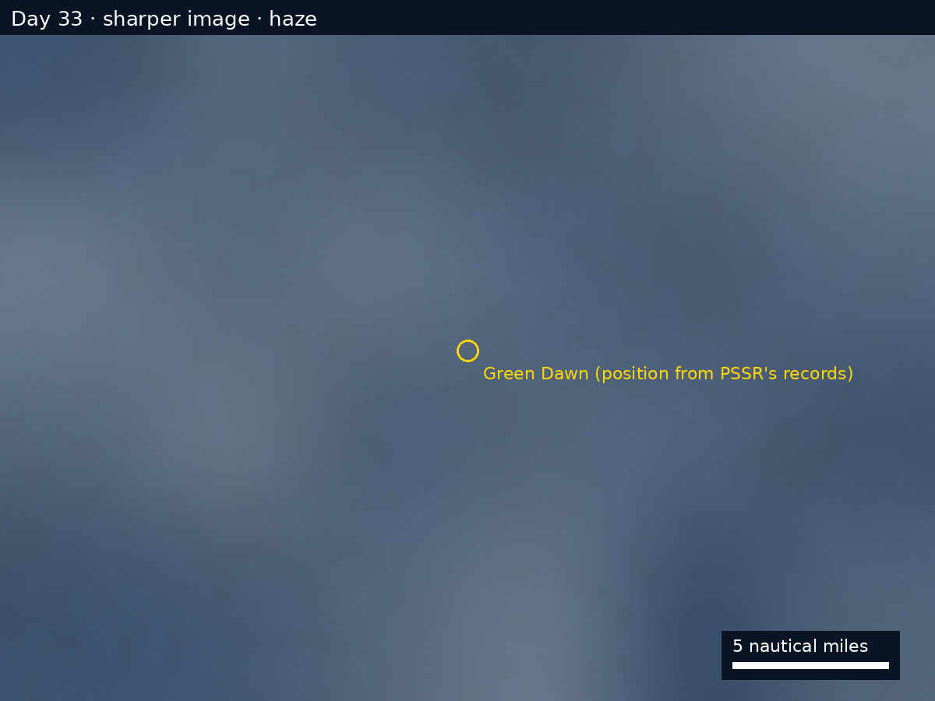
Image 3 — Day 33, sharper image, haze. The area shown is about 30 nm across.

4. TECHNICAL NOTES
- Satellites record the light reflected from the top few meters of the sea. They show nothing below that depth.
- Color alone does not identify a material. Fine sediment, plankton blooms and other materials in the water can look alike.
- Cloud, haze, sun glint and whitecaps hide the sea surface or change how it looks.
- Each pixel of the wide view covers about 250 m; each pixel of the sharper image covers about 10 m. The images reproduced here are cropped to the area around the Green Dawn.
- The lengths of the streak are estimated from the images and rounded.
- Brightness and contrast have been adjusted in the same way for all images of each kind. No other processing has been applied.
- The position of the Green Dawn is marked from PSSR's records produced to the Office.

