The Black Tide
From MirPedia, the free encyclopedia of Mir. This article covers the Black Tide. For the proceedings arising from it, see The Lumen Prospect (Case No. HCM-DIII-023).
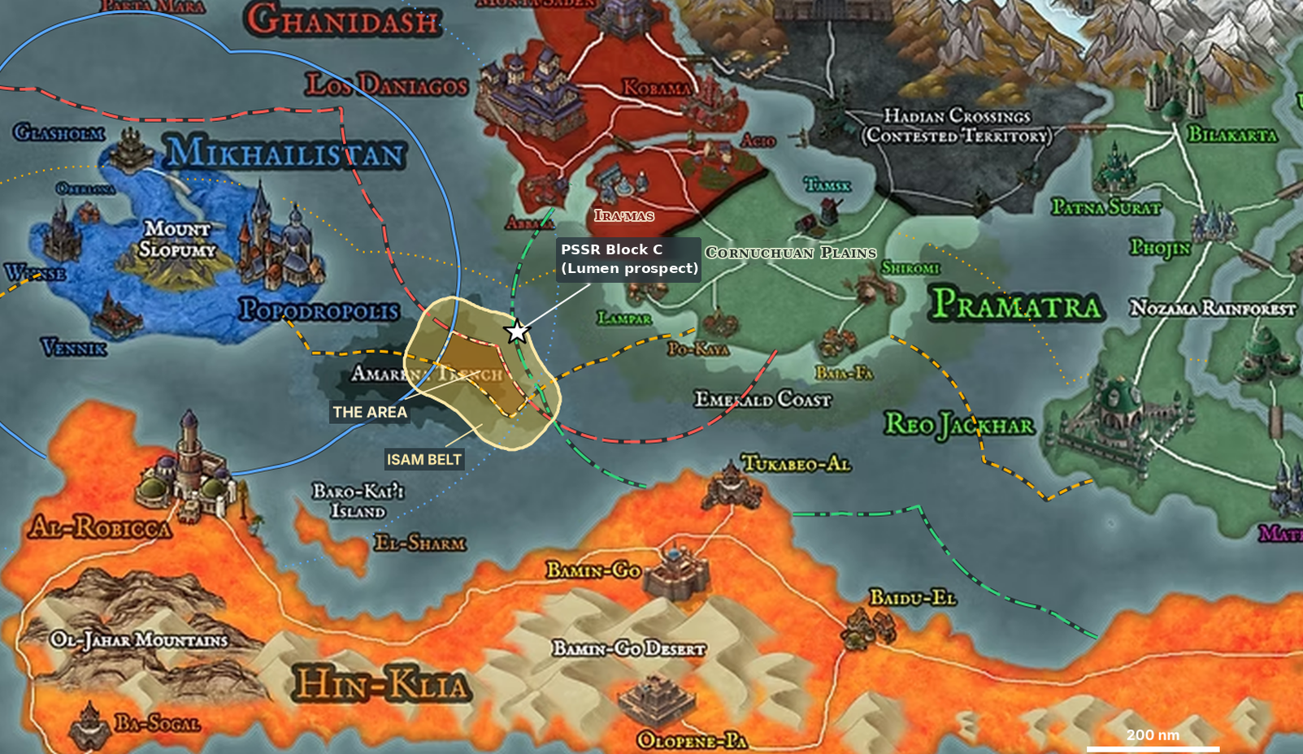
The Amarena Sea, with the Amarena Trench, the ISAM belt around it and PSSR Block C.
The Black Tide | Details
Period | Day 0 (Hurricane Yolanda) to Month 6
Location | PSSR Block C, Amarena Sea; the Ira'ma Strait, the Cornucha Narrows and Lake Haida
Operator | Patna Surat Sea Resources (PSSR)
Regulator | International Seabed Authority of Mir (ISAM)
Production vessel | Green Dawn
Communities affected | Lampar, Ira'mas, Po-Kaya, Abbaba, Baia-Fa, Acio and Tamsk; the Beli fishers of Lake Haida; the Ghani and Kotos communities of the Mokeng River
Proceedings | Case No. HCM-DIII-023, High Court of Mir, Division III

Contents
- Background
- The Lumen Project
- Hurricane Yolanda
- The Die-off
- Lake Haida and the Black Mud
- The Trout Run
- Responses
- The Proceedings

1. Background
The Amarena Sea is a semi-enclosed sea between the northern landmass of Mir and Hin-Klia. Its coasts belong to Ghanidash, including the peninsula of Abbaba; to the Cornuchuan Plains; to Pramatra, whose own coast at Reo Jackhar lies in the east; to the island state of Mikhailistan in the west; and to Hin-Klia, whose coast runs the length of the southern shore. Near the middle of the sea lies the Amarena Trench, the only seabed in the sea more than 200 nautical miles from every coast.
Under the Agreement on Nodules, Common Heritage and Ocean Resources of the Amarena Sea (ANCHOR), which entered into force with the Mir Convention on the Law of the Sea, the Trench is administered by the International Seabed Authority of Mir (ISAM) as the Area. A belt of seabed about 50 nautical miles wide around the Trench is placed under ISAM for the purpose of seabed minerals. The waters above the Trench and the belt remain under the rights and jurisdiction of the coastal States. Mikhailistan and Hin-Klia reserve their claims that the Trench is part of their continental shelf; Ghanidash and Pramatra regard it as the Area.
The coasts nearest the north-eastern part of the belt are those of Ghanidash and the Cornuchuan Plains. Before Belogal's empire, the Plains were stewarded collectively by their original peoples — the Ha'pas, Kotos and Oxori, later joined in the Taysha Confederacy; the Morokhar; and the Ölafen — in a way that balanced their use of the land and waters with nature. Belogal's empire, built on the minerals it extracted from the Ölafen mountain lands, seized the Plains and later annexed them. Seven towns of the original peoples remain on the Plains: Ira'mas (Ha'pas), Acio (Kotos), Lampar (Oxori), Po-Kaya and Baia-Fa (Morokhar), and Tamsk and Shiromi (Ölafen), among the last places where the Ölafen were never displaced. Shellfish and fish are part of the diet and trade of the coastal towns. Since the Great Hadian War, the Plains have been administered by Ghanidash and Pramatra and claimed by Belogal. No final settlement on the status of the Plains had entered into force when Hurricane Yolanda struck.
North of the Plains, the Ira'ma Strait runs between Abbaba and Ira'mas. From the strait, a channel known as the Cornucha Narrows leads to Lake Haida, a tidal, brackish lake bordered by Ghanidash to the west, Pramatra to the south and, on its north-eastern shore, the communities of the Beli fishers. The Mokeng River comes down from the Saden Mountains, past the Ghani communities along its banks, and enters Lake Haida at its north-western corner over a short drop. Each year migratory trout pass through the lake and up the Mokeng to spawn in its headwater streams, where the Kotos live.

2. The Lumen Project
After the Great Hadian War, reconstruction and the green energy transition raised demand for minerals across Mir. Rare earth elements, used in the magnets of electric motors and wind turbines, were in particular demand: Mir has some sources throughout the different countries, but their supply falls far short of the expected need.
Glasholm Minerals Group (GMG), a long-established company of Mikhailistan with mines and refineries across Mir, held an exploration license in the belt before the war, sponsored by Mikhailistan, and carried out a small pilot collection test there in calm weather. Its exploration was suspended during the war. After the war, GMG founded Patna Surat Sea Resources (PSSR) in the coastal city of Patna Surat, in Pramatra. Petrogan, the national oil company of Hin-Klia, holds 20 percent of PSSR's shares and engineered its riser and return line. PSSR's sponsoring States are Mikhailistan and Pramatra.
After the war, ISAM's Council added to its exploitation rules, the DEEP Regulations, an expedited procedure for "strategic minerals for reconstruction," with rare earths as the only listed minerals. It shortened the review by ISAM's Legal and Technical Commission to 30 days, and the periods for public comment and for the Council to act to 15 days each. PSSR applied for a license for PSSR Block C, the Lumen prospect, presenting its plan as the Clean Energy Rare Earth Project. Its published summary named rare earths as the principal product, with nickel, copper, cobalt and manganese as co-products. The Secretary-General found the application eligible for the expedited procedure, and the Commission recommended approval. The period allowed for the Council fell between its regular sessions, no member requested a meeting, and the plan of work was deemed approved. PSSR's license was the first commercial exploitation license issued for the Trench and the belt.
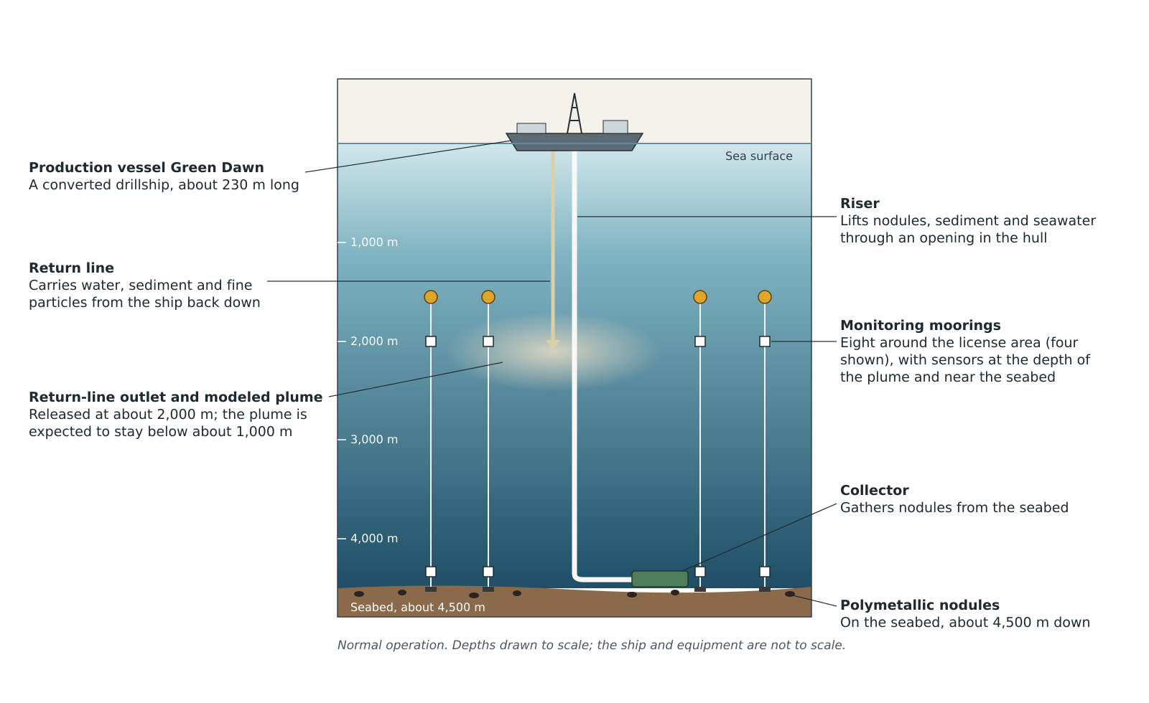
The mining system as designed. A collector gathers nodules from the seabed; the riser lifts them to the production vessel; the return line carries water, sediment and fine particles back down and releases them deep in the water column. Simplified; not to scale.
Polymetallic nodules lie on the seabed at Block C, about 4,500 meters down. PSSR's production vessel, the Green Dawn, is a converted drillship about 230 meters long. A collector moves across the seabed and gathers the nodules. A pipe called the riser, lowered through an opening in the middle of the hull, lifts nodules, sediment and seawater to the ship. On board, the nodules are separated, and the remaining water, sediment and fine particles are sent back down through a second pipe, the return line, which releases them far below the surface. PSSR's monitoring plan placed moorings with sensors in the deep water around the license area.
PSSR carried out commercial production at Block C for several years before Hurricane Yolanda. Its royalties are held in ISAM's special account, to be shared equitably among the peoples of Mir under criteria that ISAM's Assembly has not yet adopted. A draft formula was on the Assembly's agenda when Yolanda struck.

3. Hurricane Yolanda
Yolanda formed as a tropical depression two days before it reached Block C (Day −2) and was forecast to pass west of the license area as a tropical storm. On Day −1, PSSR suspended lifting and all discharges and secured the riser, which remained connected to the collector, as its emergency response plan provided for a tropical storm.
Yolanda then strengthened far faster than forecast. It became a hurricane early on Day 0 and, by the time it passed about 25 nautical miles west of Block C that night, it was a Category 4 hurricane with maximum sustained winds of about 150 mph (130 knots). During the storm, the riser ruptured.
On Day 1, PSSR reported a "contained sediment incident" to ISAM's Secretary-General and announced that the damaged riser would be repaired. The Secretary-General transmitted the report to the Commission and asked PSSR for follow-up reports, which PSSR provided, including images of the repaired riser. PSSR repaired and inspected the riser and resumed production on Day 4. On the basis of PSSR's reports, the Secretary-General confirmed the incident closed.

4. The Die-off
On Day 24, shellfish began to die along the coast at Lampar. The deaths were at first blamed on the hurricane, and local media reported them as storm damage. Fishers reported the deaths to their own organizations: the Southern Plains Fishers' and Shellfish Growers' Association, whose members fish from Lampar, Po-Kaya, Baia-Fa and Tamsk, and the Ira'ma Strait Fishers' Cooperative, whose members fish from Ira'mas, Acio and Abbaba.
On Day 28, a second storm passed west of the Ira'ma Strait and drove water from the sea into the strait and the Cornucha Narrows. Deaths followed at Ira'mas and Po-Kaya and, more lightly, among the Ghani fishers of Abbaba, in Ghanidash, where the last deaths were recorded on Day 34.
At the shore, the water looked no different from the murky water that follows any storm. But the fishers noticed that shellfish kept dying after the storm water had cleared, including on beds the storm had not reached, and that the dying shellfish carried fine dark grit in their gills and gut. The Association sent samples from Po-Kaya to the Cornuchuan Plains Agricultural University at Shiromi, which was founded and is governed by the councils of the five original peoples. On Day 40, the University sent its results to ISAM's Secretary-General: the samples contained metal-bearing fine particles matching the composition of nodule material.
On Day 41, the Secretary-General ordered PSSR to suspend lifting and all discharges and to inspect its whole mining system, and notified the members of the Council, the sponsoring States and the States likely to be affected. PSSR's inspection found a crack in the upper part of the return line. The discharge was stopped on Day 42. At a special meeting, the Council decided without a vote to maintain the suspension until further notice. By Day 42, shellfish were dying at Baia-Fa.
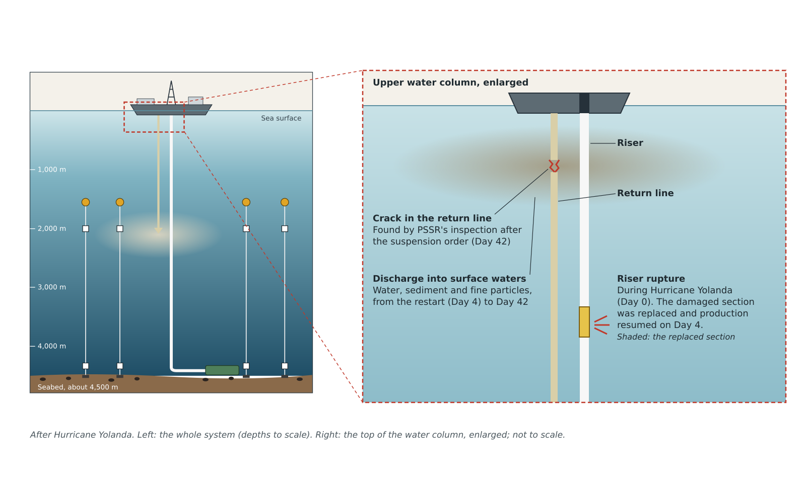
Where the riser ruptured during the storm, and where PSSR's inspection on Day 42 found the crack in the return line. Simplified; not to scale.

5. Lake Haida and the Black Mud
On Day 49, a third storm stirred up sediment that had settled along the coast and carried it through the Narrows into Lake Haida, reaching Acio and the fishing grounds of the Beli fishers on the lake's north-eastern shore. On Day 56, deaths began at Tamsk.
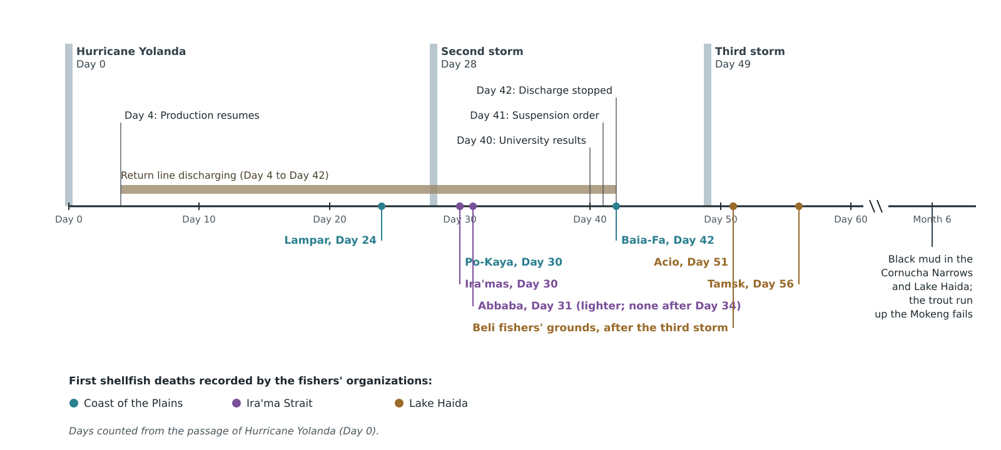
Timeline: the first shellfish deaths recorded at each place, by day, from Lampar on Day 24 to the black mud in the Narrows and Lake Haida in Month 6.
By Month 6, the open sea had largely cleared, but a layer of black mud lay on the bottom of the Cornucha Narrows and Lake Haida. Fine particles tend to collect where river water meets seawater, and the decay of dead shellfish and fish takes oxygen from the water near the bottom, which turns bottom mud black. Fishers on the lake reported black mud filling their nets and traps.

6. The Trout Run
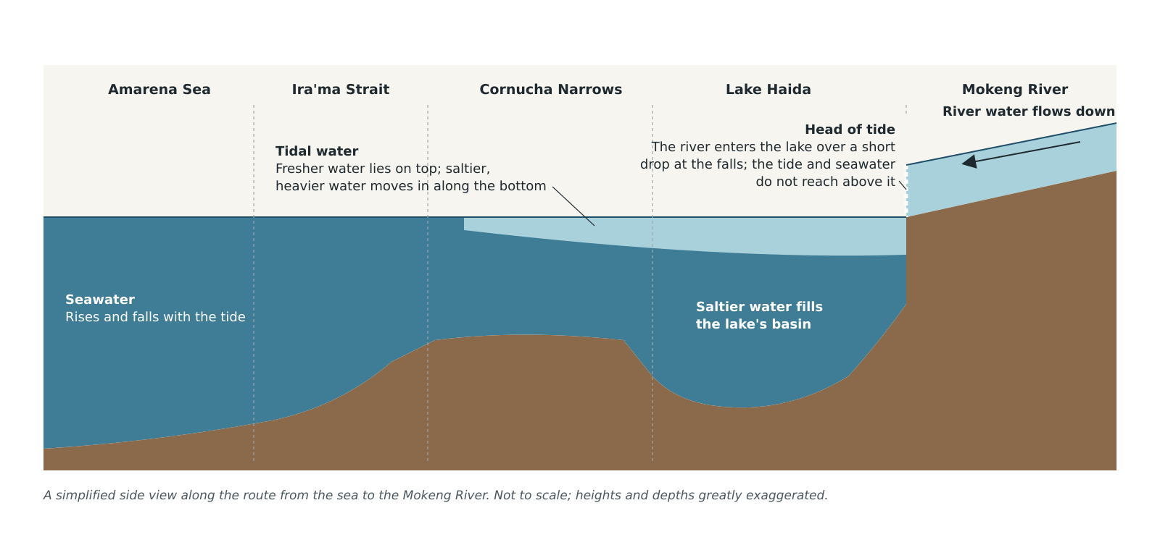
Seawater and the tide reach Lake Haida through the Cornucha Narrows. The Mokeng River enters the lake over a short drop, above the reach of the tide.
The Mokeng River ran clear through the following migration season (Month 6), with normal flow. The trout run failed. The Ghani and Kotos communities, who count the fish at the falls where the Mokeng enters Lake Haida, counted a few hundred trout, against more than ten thousand in most earlier seasons. Almost none reached the headwater streams. The councils of the Ghani and Kotos communities attribute the failure to the contamination of the Narrows and the lake through which the trout must pass.

7. Responses
Affected communities petitioned the Office of the Prosecutor of the High Court of Mir under the Protocol to the Statute on Environmental Responsibility Proceedings (REEF). Petition 12, from the councils of Lampar, Ira'mas, Po-Kaya, Baia-Fa, Acio and Tamsk with the two fishers' organizations, was received in Month 3, and the Office opened an investigation. Petition 14, from the Beli fishing communities of Lake Haida, followed in Month 4, and Petition 21, from the Ghani and Kotos communities of the Mokeng River and its Saden headwaters, in Month 8. Both were joined to the investigation.
The Secretariat of the United Mirians convened an independent panel of marine scientists to assess the effects of the spill, and the panel's assessment has been published. PSSR's operations at Block C remain suspended.

8. The Proceedings
About a year after Hurricane Yolanda, the Office of the Prosecutor filed Application No. HCM-DIII-023, The Lumen Prospect, against PSSR and ISAM before Division III of the High Court of Mir, the Maritime and Environmental Chamber. The Application sets out four counts: failure to prevent serious harm to the marine environment; failure to detect, warn and respond; misleading representations in licensing; and harm to inland communities. PSSR has said that it followed its approved plans and that Hurricane Yolanda was an exceptional storm. ISAM has said that it followed the procedures in force and acted on the information reported to it. For the charges, the legal framework and the evidence, see the case page for HCM-DIII-023.
This article reflects publicly available information about the Black Tide. It does not incorporate restricted documents. Interpretations of the spill's causes and consequences remain contested. MirPedia articles are written from a neutral point of view and do not represent the position of any state, company or institution.
Categories: Amarena Sea; Seabed mining; Environmental disasters of Mir; Cornuchuan Plains; Lake Haida; Original Peoples of the Land; International Seabed Authority of Mir; Environmental responsibility proceedings.
This page was last edited by the MirPedia community. MirPedia is a simulation resource for POLS 369 Politics and International Law, SUNY Potsdam.

